ALPMS

(Automated Loan Processing & Monitoring System)

Group 04

**ALPMS**

**(Automated Loan Processing & Monitoring System)**

**By**

**Group 04**

|  |  |
| --- | --- |
| 1621176 | Syed Shams Elahi |
|  |  |
|  |  |
|  |  |
|  |  |
|  |  |
|  |  |



INDEPENDENT UNIVERSITY, BANGLADESH

**February, 2018**

**Supervisor: Dr. Mahady Hasan, Asst. Professor, CSE**

All rights reserved. This work may not be

Reproduced in whole or in part, by photocopy

Or other means, without the permission of the author.

© group0X 2018

1

ALPMS

(Automated Loan Processing & Monitoring System)

Group 04

**Approval**

This report entitled

**ALPMS**

**(Automated Loan Processing & Monitoring System)**

By

Group 0X

Has been approved by

Instructor of Database Management Course

The Department of Computer Science and Engineering,

Independent University, Bangladesh.

(Sign)

Instructor: **Dr. Mahady Hasan, Asst. Professor, CSE**

The final copy of this report has been examined by the signatory and we find that both the content and the form meet acceptable presentation standards of scholarly work in the above mentioned discipline.

2

ALPMS

(Automated Loan Processing & Monitoring System)

Group 04

**Originality Statement**

I hereby declare that this submission is my own work and to the best of my knowledge it contains no materials previously published or written by another person, or substantial proportions of material which have been accepted for the award of any other degree or diploma at IUB or any other educational institution, except where due acknowledgement is made in the report. Any contribution made to the research by others, with whom I have worked at IUB or elsewhere, is explicitly acknowledged in the report. I also declare that the intellectual content of this report is the product of my own work, except to the extent that assistance from others in the project's design and conception or in style, presentation and linguistic expression is acknowledged.

|  |  |
| --- | --- |
| 1621176 | Syed Shams Elahi |
|  |  |
|  |  |
|  |  |
|  |  |
|  |  |
|  |  |

3

ALPMS

(Automated Loan Processing & Monitoring System)



Group 04

**ACKNOWLEDGEMENT**



Dr. Mahady Hasan

Syed Shams Elahi

4

ALPMS

(Automated Loan Processing & Monitoring System)

Group 04

**Reference:**

[*www.sreda.gov.bd/*](http://www.sreda.gov.bd/) *, 5/02/18*

[*www.biffl.org.bd/*](http://www.biffl.org.bd/) *, 5/02/18*

[*www.idcol.org*](http://www.idcol.org/) *, 5/02/18*

**Appendix** (To reduce the size of the main report an extension of the report is given in this area. The mainreport should refer to this area. The part that is so important that you can’t exclude it from the report neither can include in the main part is normally placed in this section.)

5

ALPMS

(Automated Loan Processing & Monitoring System)

Group 04

**Contents**

|  |  |
| --- | --- |
| Originality Statement.................................................................................................................................... | 3 |
| Background of the Project............................................................................................................................ | 8 |
| Background of the Organization................................................................................................................... | 9 |
| SREDA.......................................................................................................................................................... | 10 |
| Vision....................................................................................................................................................... | 10 |
| Mission.................................................................................................................................................... | 10 |
| Goal......................................................................................................................................................... | 11 |
| Objectives............................................................................................................................................... | 11 |
| Organogram........................................................................................................................................... | 11 |
| IDCOL........................................................................................................................................................... | 14 |
| Vision....................................................................................................................................................... | 14 |
| Mission.................................................................................................................................................... | 14 |
| Goal......................................................................................................................................................... | 15 |
| Objectives............................................................................................................................................... | 15 |
| Organogram............................................................................................................................................ | 15 |
| BIFFL............................................................................................................................................................ | 16 |
| Vision....................................................................................................................................................... | 16 |
| Mission.................................................................................................................................................... | 17 |
| Goal......................................................................................................................................................... | 17 |
| Objectives............................................................................................................................................... | 17 |
| Organogram............................................................................................................................................ | 18 |
| Objective of the Project.............................................................................................................................. | 19 |
| Scope of the Project.................................................................................................................................... | 19 |
| Existing Business System with Rich Picture................................................................................................ | 20 |
| Existing business System with rich picture description.............................................................................. | 21 |
| Existing processes along with six system elements (Loan type a).............................................................. | 22 |
| Existing Problems & Analysis of the problem along with solution (Loan type a)....................................... | 30 |
| Existing processes along with six system elements (Loan type B).............................................................. | 34 |
| Existing Problems & Analysis of the problem along with solution (Loan type b)....................................... | 37 |
| Proposed Business System with Rich picture............................................................................................. | 43 |
| Proposed system rich picture description (loan type A)............................................................................. | 45 |
| 6 |  |

ALPMS Group 04

(Automated Loan Processing & Monitoring System)

Proposed processes along with six system elements (LOAN a) 46

Existing Problems & Analysis of the problem along with solution (Loan type a) 52

Proposed process rich picture with description (Loan type B) 56

Proposed processes along with six system elements (LOAN B) 57

Existing Problems & Analysis of the problem along with solution (Loan type B) 61

Loan Type AN ERD **Error! Bookmark not defined.**

Loan Type B ERD 66

Loan type A relation schema 67

Loan type B relation schema 70

Normalized form of loan type A entities 74

Normalized form of loan type b entities 76

Process modeling of loan type a 78

Process modeling of loan type B 93

Loan Type A 102

Loan Type B 103

Loan type A Data Dictionary 104

Loan type b data dictionary 120

Physical System Design 139

GUI and Query 147

Problems faced 154

Solution 154



7

ALPMS Group 0X

(Automated Loan Processing & Monitoring System)

**BACKGROUND OF THE PROJECT**

As of this time, the loan process being implemented by Infrastructure Development Company Limited (IDCOL) and Bangladesh Infrastructure Finance Fund Limited (BIFL) - the Implementing Financial Institutions (IFIs) relies on a series of manual, and unorganized steps.

In our CSE 303 Database Management System course, we have been tasked with analyzing the complete business model, critique it, and based on our observations develop an Automated Loan Processing and Monitoring System. The system proposed will have to take full advantage of automation, sustainability and usability by organizing the loan management process into a more organized, systematic, logical, procedural, and sound manner. It software will also enable the stakeholders to monitor and record the progress of their process in the organization. It will enable the organization to have more confidence over its data by storing information regarding the progression, reports, eligibility conformities, etc. more accurately and efficiently than as the current model. No critical and sensitive information will be saved locally so as to avoid being compromised. Hence it will utilize cloud technology. The amount of work on part of the Financial Institutions in carrying out the loan process manually is very cost expensive, as there can be discrepancy at any stage of a quite large process. Thus preventing them from closing the loans by the agreed-upon due date. The automated system proposed, having magnified down to all the drawbacks, will provide a higher efficiency and automation, reducing manual and cumbersome tasks, and overall, lower the costs of the organization greatly.

Our software is finely tailored to suit the requirements of our clients - the proponents, implementing financial institutions (IFI), Sustainable and Renewable Energy Development Authority (SREDA), participating distributor (PD), Japan International Cooperation Agency (JICA) and also Ministry of Power, Energy and Mineral Resources (MPEMR). The business model of the overall organization sums up to these major work blocks:

**Rich Picture of the Organization**

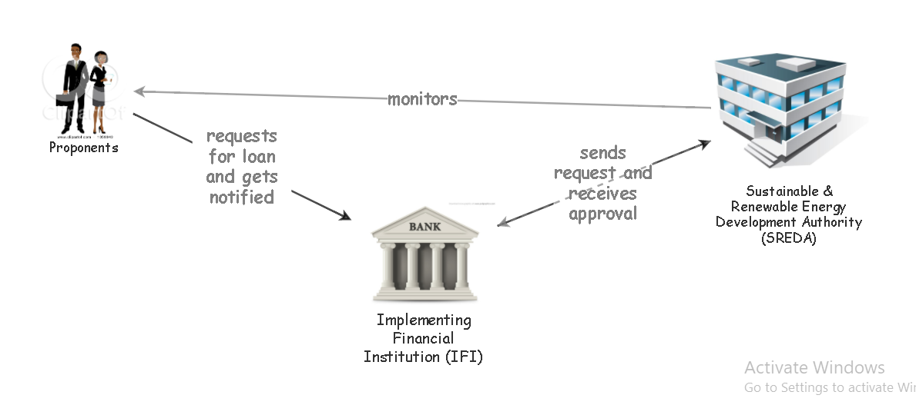

There are two loans for extending the EE&C promotion financing loan, which are:

(a) A-type loan: IFIs lend money directly to the companies and organizations who are introducing the EE&C equipment, and;

(b) B-type loan: There is an intermediary distribution organization called “participating distributors (PDs)” who supply EE&C equipment (home appliances).

**Background of the Organizations**

With the rapidly depleting natural resources, and deteriorating environmental changes, the search for a greener, more sustainable path to growth has been direr than ever. One of the findings that came up is the Energy Efficiency & conservation (EE&C) Promotion Financing Project. It has been built upon the sole purpose of achieving more long-lasting greener development of Bangladesh using state of the

Art quality assured EE&C materials. This is expected to bring down carbon and other greenhouse gas emissions by a drastic X___ Insert Value here ___ %, keeping in par with the demand and supply in the economy. In the December of 2015, in response to Bangladesh’s seventh five-year plan. The Japanese Government (represented by JICA), extended the concessional loan (11.5 billion JPY) to the Government of Bangladesh (represented by Finance Division, Ministry of Finance) with an interest rate of 0.01%.

Three organizations are in direct contact with the System.

They are:

**Administrative authority**: Sustainable and Renewable Energy Development Authority (SREDA)

**Implementing Financial Institution**: Infrastructure Development Company Limited (IDCOL)

**Implementing Financial Institution**: Bangladesh Infrastructure Finance Fund Limited (BIFFL)

**Sustainable and Renewable Energy Development Authority (SREDA):**

**Background of SREDA:**

C:\Users\RATULS~1\AppData\Local\Temp\284c308b.tmp\img00001.PNG

SREDA implements renewable energy and energy efficiency issues of the Government. It promotes sustainable energy and growth using new technologies which it also pilots. It standardizes and labializes the products for RE and EE. It also initiates the expansion of new technologies and helps create a sound environment for the investors. Renewable Energy (RE) and Efficient Energy (EE)’s development and promoting, and gene capacity development is also looked after by SREDA. Furthermore, SREDA establishes a platform for national and international organizations to interact.

**Visions of SREDA:**

SREDA is a champion of sustainable energy and paves the way for an energy conscious nation to guarantee energy security and to bring down carbon emission.

Mission of SREDA:

To organize and invest in the development of green energy and energy efficiency-

* To increase the usage of renewable energy and reduce dependency on fossil fuel,

* To take fitting actions for saving energy

* To assess continuously for more potential renewable energy options

**Goals of SREDA:**

To fulfill its visions and mission, SREDA sets the following goals -

* Increase Renewable Energy generation

* Increase the proportion /amount of energy saving

.

**Objectives of SREDA:**

To achieve the goals, the objectives are-

* By the year 2020 10% (2000 MW) of the total power generation will be composed of renewable energy.

* By the year 2021 the energy saving will be 15% and 20% by 2030 of total energy consumption.

**Organogram of SREDA:**

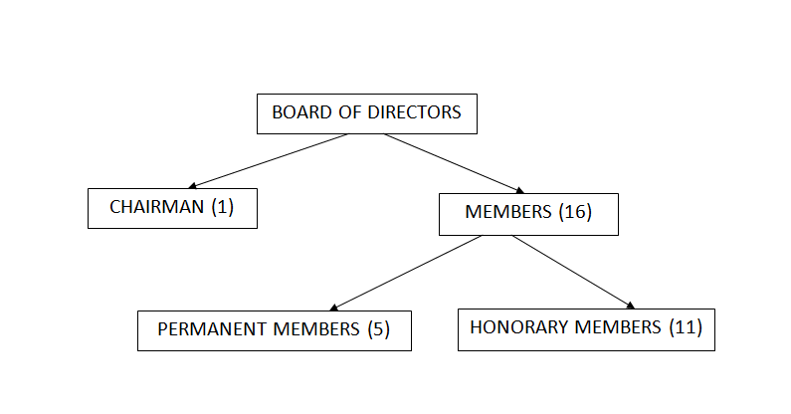

**Board Structure of SREDA:**

The general direction and management of the Authority is vested on the Board. The Board is constituted by Chairman and members, not more than sixteen. Chairman and five members are the honorary and full time members and eleven members are nominated by the government from different Ministries/Divisions and representatives from academicians, professionals, technical experts, non-government organizations (NGOs) and business communities. They are officiated for the term of 2 years from the date of their nomination.  The Board takes all the policy decisions of the Authority.

**Organizational Structure of SREDA:**  
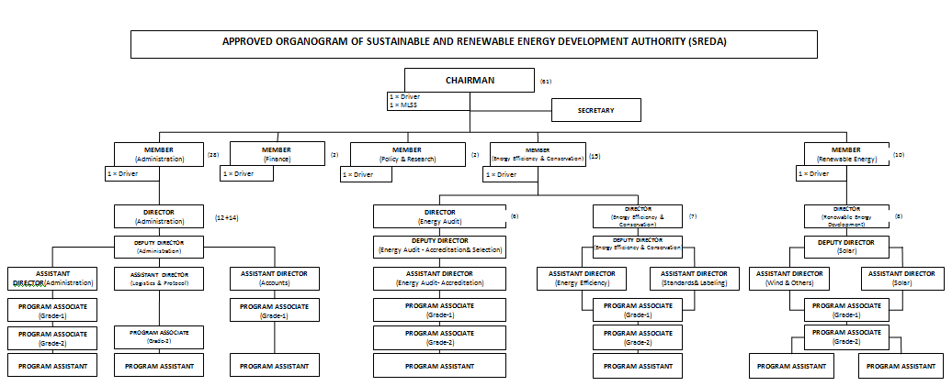

**Background of Infrastructure Development Company Limited (IDCOL):**



Infrastructure Development Company Limited (IDCOL), established on 14 May 1997 by the Government of Bangladesh. Bangladesh Bank licensed the company as a non-bank financial institution (NBFI) on 5 January 1998. Since its creation, IDCOL has been a major contender in bridging the financing gap for developing medium to large-scale infrastructure and renewable energy projects in the country. It is the current market leader in private sector energy and infrastructure financing in Bangladesh.   
  
an eight-member independent Board of Directors comprising four senior government officials, three representatives from the private sector and a full time Executive Director and Chief Executive Officer manages IDCOL. It has a small and multi-skilled work force comprising financial and market analysts, engineers, lawyers, IT experts, accountants and environmental and social safeguard specialists. IDCOL's stakeholders consist of the government, private sector, NGOs, multilateral and bilateral institutions, academics and the people of Bangladesh at large.

**Vision of IDCOL:**

To help ensure economic growth of the country and enrich the living standard of the inhabitants through maintainable and green investments.

**Mission of IDCOL:**

To reinforce and enhance the private sector’s contribution in promotion, development, and financing of infrastructure as well as green energy, and energy efficient projects in a long lasting manner through public-private-partnership initiatives.

**Core Values of IDCOL:**

Global Standard and Competence: IDCOL is designed to deliver financial services to the clients keeping on par with global standards and competence.

Transparency and Integrity: IDCOL is a firm believer of keeping transparency and integrity in all tasks conducted by the Company.

Social Responsibility: IDCOL is inclined to play the role of a development financial institution that articulates social responsibility.

**Organogram of IDCOL:**

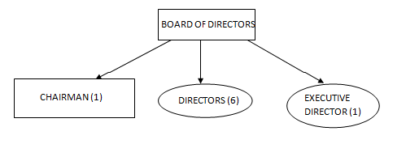

**Bangladesh Infrastructure Finance Fund Limited (BIFFL):**



**Background of Bangladesh Infrastructure Finance Fund Limited (BIFFL):**

Bangladesh Infrastructure Finance Fund Limited (BIFFL) is the largest Government owned Non-Banking Financial Institution in Bangladesh which has authorized capital and paid up capital of BDT 100 billion and BDT 20.10 billion respectively. It addresses the importance of infrastructure growth vis-à-vis not sufficient investment in that specific sector, with a foresight to raise awareness of an attractive environment for sustainable private investment.

As a portion of this, BIFFL brought to inception in 2011 as a special purpose vehicle to mobilize the PPP budget through financing infrastructure projects partnering with private sector investors.  
Moreover, to keep up sustainable development, BIFFL is also dedicated to save the environment and use economically friendly actions in all aspects which are of its utmost consideration while prioritizing any investment transaction.

**VISION of BIFFL:**

Increase progression of economic efficiency by harnessing the relative merits and strengths of Public and Private Sector via financing Infrastructure Projects.

**MISSION of BIFFL:**

* To act as a professional Financial Institution by implementing the globally recognized best practices and sustaining the utmost level of moral and ethical standards.

* To raise awareness of the country’s economic growth by providing and encouraging Private Sector Investment in all infrastructure projects.

* To be in support of sustainable economic growth of Bangladesh through facilitating Infrastructure Development.

**GOAL of BIFFL:**

* To facilitate long-term finance to critically vital infrastructure projects.

* To accelerate co-financing from private financial sources.

* To provide a unique vehicle for capital market development by exploring a number of avenues to capture domestic and foreign investment within the contexts of a robustly designed and well-governed investment vehicle.

**Organogram of BIFFL:**

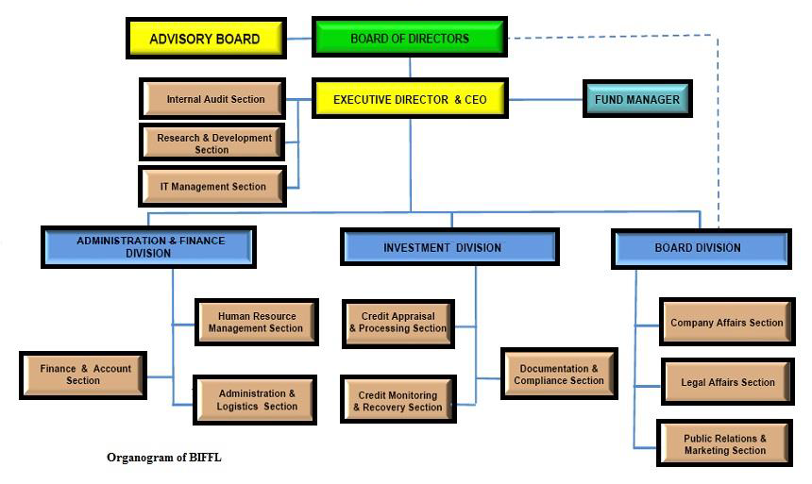

**OBJECTIVE OF THE PROJECT**

 The main objectives of the project are given below:

• To store and manage the progress of the project in the MIS.

• To record energy consumption and production related information in the MIS.

• To maintain the consistency and integrity of data.

• To speed up the collecting processes, and ensure data safety by using cheap encrypted secure online storage (Drobox) to allow data uploads.

• To automate the loan to process it efficiently.

• To reduce manual data entry.

• Ensure cleaner data by using software to check for and report errors in several phases.

• To reduce paperwork.

• Make the site more intuitive and add a chat bot to the site so as to make it more user friendly and ensure thorough information exchange from both sides.

• To speed up the loan process by processing in parallel.

• To speed up the meeting processes by using an online chat interface to conduct meetings between in-organization stakeholders and specific meetings with off-organization stakeholders.

 • To avoid processing duplicate application.

• Making sure to keep a human level checking mechanism in the vital processes.

• Not storing sensitive data or personal information locally to avoid any casualties regarding security.

• Use artificial intelligence to get intuition from data and past data of the proponents so as to help make more conclusive decisions.

Overall the main objective of the project is to propose and design a system where the stakeholders can get information, communicate with each other, make intuitive and solid decisions, get access and store information about the loan projects efficiently, and the data will be processed and handled finely to produce clean and validated data, without the risk of data loss and security casualty.

**SCOPE OF THE PROJECT**

In this section, we will describe the objectives of the project thoroughly for a clearer understanding of the project. Four main users have been identified in this system. Sub-project proponents, IFI, SREDA, and PD. We will zoom in on the activities they can do throughout this system in form of objectives.

**Online form & Contact details:**

 Sub-project proponents and PDs can view the pre-screening application forms, technical prescreening application forms. They can also fill up all the forms online, where forms will have computerized validators to ensure the data is clean. They will also have a chat bot on the site to make sure all the details and information publicly available on the site can be provided in an intuitive user friendly manner so as to avoid data loss. And the chat bot can accept and handle general queries and forward the queries requiring more expert support. They will have access to all vital information both via chat and the website.

**Checklists, annexes, documents, instruction manuals:**

All fixed documents, checklists, annexes, and instruction files will be available as a softcopy both downloadable and live-viewable on the website. Those which need to be inputted data can be done online and tracked via appropriate parties.

**File uploads**:

Documents and files can be uploaded online to a secure and cost friendly web server (Drop Box) which will ensure greater security with documents and less paper to be managed and handled.

**Name clearance:**

Name clearance evaluation and the registration for the clients will be tracked by both IFI & SREDA. This will ensure no data loss, better evaluation, efficient for decision making and keeping better track for the progression of the cases.

**Equipment List:**

Sub-project proponents and PDs can go through the list for eligible Energy efficient equipment list for their convenience before applying for loans

**Eligibility Check list:**

Eligibility check list for the loans will be saved in the system for more accurate analysis by the IFIs and SREDA.

**Notifying Rejection/Acceptance of Loan:**

This system will enable the IFI and SREDA to make their decision and the software will automatically notify the clients of their rejection/acceptance of their cases via email and SMS. And if the case is rejected it will also let the client know the reason for rejection. Premade templates for the email and SMS will be filled with the IFI and SREDA’s feedback. The clients will be asked to verify they received the notice via logging in to their account.

**Activities of IFI Employee/Manager/B.O.D:**

This system will have separate secure accounts and privileges for managers, employees and Board of directors of IFI to evaluate, save results and notify the rejection/acceptance of the loan cases.

**Activities of SREDA Employee/Manager/B.O.D:**

SREDA employees, B.O.D will also be able to monitor the processing of the loan cases and track the projects for which loan has been granted, it can also save and modify reports.

**Templating and Notifying System:**

Premade templates will be available, which will be filled based on the in-organization user’s inputs on the site. This will be rendered as email and SMS and sent to those in concern. Laborious tasks like reminding, informing and requesting will be automated using this part of the system.

**Chat interface:**

Meetings and communication can be conducted online via the chat interface (supporting both text, voice, and video chats, and window and file sharing). This will speedup up the setup time taken to conduct in-person meetings, and can be recorded and copies will be send to stakeholders to be reviewed in the situation some information needs clarifying.

**Artificial intelligence:**

Artificially intelligent software will be fed past data gathered on the clients and will generate predictions based on them to

**Part I**

**A-type Loan: Formulation and Implementation**

**A-type Loan Appraisal Procedure**

|  |  |  |  |  |  |  |  |
| --- | --- | --- | --- | --- | --- | --- | --- |
| Process  Number | Process  Name | Existing Six System Elements | | | | | |
| Human | Non Computing Hardware | Computing Hardware | Software | Database | Comm.  Network |
| 11 | Preparation | PIU Secretariat [Provides information] |  |  |  |  | IFI’s Website |
| 12 | Receiving Loan Applications | Officer in charge[Responds to queries, Register details, Arrange meeting] | Forms,  Documents,  Printer,  Pen |  |  |  | Phone,  Email, |
| 13 | Preliminary Eligibility Checking | Officer in charge [Check Annex and Documents, Record results, Discuss with manager] | Forms,  Documents,  Annexes,  Printer,  Pen |  |  |  |  |
| 14 | Name Clearance | Officer in charge [Check documents, Collect information, Register result,  Submit to Manager, Communicates with Proponents, Recheck documents, Informs results],  Manager [Discussion],  PIU Secretariat [Identifies and registers products and case] | Forms,  Documents,  Annexes,  Printer,  Pen |  |  |  | Phone |
| 15 | Submit Request to SREDA for NOC | Officer in charge [Checks, and Verifies documents and information, Submits findings to Manager, Consult with proponent, Submit to SREDA],  Manager [Discuss, Approve],  SREDA [Approve, Disapprove, Set conditions] | Forms,  Documents,  Annexes,  Printer,  Pen |  |  |  | Telephone |
| 19 | Forwarding NOC or  Rejection Letter to Proponent | Officer in charge [Checks, Registers, Verifies Data, Handles Documents],  SREDA [Sends Documents] | Letter,  Documents,  Printer |  |  |  |  |
| 20.1 | Due Diligence | Officer in Charge [Inspects Data],  Manager [Verifies Data] | Sheets,  Paper,  Printer,  Forms,  Pen |  |  |  | Telephone |
| 20.2 | Conducting Due Diligence | Officer in Charge [Requests documents, Registers application, Conducts offsite check],  Manager [Goes to offsite checking, Approves or disapproves case] |  |  |  |  | Telephone |
| 21 | Loan Decision | Officer in charge [Prepares documents,  Collects information from sources, Reports details, Notifies PIU Secretariat and collects documents, Discusses with PIU Secretariat], Manager [Approve or Disapprove, Confirm information validity], PIU Secretariat [Decides on Loan, Discusses with Manager] | Pen,  Paper,  Printer,  Forms,  Documents |  |  |  | Telephone |
| 22 | Documentation  or loan | Officer in Charge [Prepares documents, validates conditions and status, Register application details].  Manager [Sanctions loan, Attests application, Gives Approval] |  |  |  |  |  |
| 23 | Disbursement | Officer in Charge [Request to open account, Register account, Verify status, Transfer money] | Documents,  Pen,  Paper,  Printer |  |  |  | Telephone |
| 24.1 | Completion of Repayment | Manager [Confirm balance],  Officer in Charge[Record balance] |  |  |  |  |  |

POINT NUMBERS MISSING!

**Part II**

**B-type Loan: Formulation & Implementation**

**B-type Loan Formulation Implementation**

**Procedure**

|  |  |  |  |  |  |  |  |
| --- | --- | --- | --- | --- | --- | --- | --- |
| Process  Number | Process  Name | Existing Six System Elements | | | | | |
| Human | Non Computing Hardware | Computing Hardware | Software | Database | Comm.  Network |
| 25.1 | Preparing Eligible Application List | Officer in Charge [Request PD for application, Verify application, discuss with SREDA PIU Secretariat to validate eligibility] | Documents,  Paper,  Pen,  Printer,  Forms,  Applications |  |  |  |  |
| 25.2 | Participating  Distributor(PD)  Selection  And  Appointment | PIU Secretariat [Formulate committee, consult with PD,  Handle applications] | Documents,  Paper,  Pen,  Printer,  Forms,  Applications |  |  |  | Telephone |
| 26.1 | Loan Disbursement to APO | Officer in Charge [Request payment, Consult with Manager and PIU Secretariat],  PIU Secretariat [Make decisions],  Manager [Engages in discussion] |  |  |  |  | Telephone |
| 26.2 | Advance Payment Procedure | Officer in charge [Request documents, Submit requests, Record transactions and application, Verify transaction], Manager [Validate, Make decisions, Confirm, Discuss] | Documents,  Paper,  Pen,  Printer,  Forms,  Applications |  |  |  | Telephone |
| 27 | Sales Record  Keeping | Officer in Charge [ |  |  |  |  |  |
| 28 | Loan  Disbursement  To PDs  (Reimbursement  option) |  |  |  |  |  |  |
| 29.1 | Adjustment  Against APO |  |  |  |  |  |  |
| 29.2 | Repayment |  |  |  |  |  |  |

**Part III**

**Monitoring for A-type Loan**

**A –type loan Monitoring Procedure**

|  |  |  |  |  |  |  |  |
| --- | --- | --- | --- | --- | --- | --- | --- |
| Process  Number | Process  Name | Existing Six System Elements | | | | | |
| Human | Non Computing Hardware | Computing Hardware | Software | Database | Comm.  Network |
| 30 | Managing  Sub-project  Implementation  Plan |  |  |  |  |  |  |
| 31 | Registration of  User-ID and  Password |  |  |  |  |  |  |
| 32.1 | Document and  Evidences on  Purchasing and Installation |  |  |  |  |  |  |
| 32.2 | On-site Inspection |  |  |  |  |  |  |
| 32.3 | Requesting sub-project owner to submit required data and to cooperate for inspection |  |  |  |  |  |  |
| 33.1 | Environmental  And Social  Performance  Report |  |  |  |  |  |  |
| 33.2 | Environmental  And Social  Management  System(ESMS)  Checklist |  |  |  |  |  |  |

**Part IV**

**Monitoring for B-Type Loan**

**B-type Loan Monitoring Procedure**

|  |  |  |  |  |  |  |  |
| --- | --- | --- | --- | --- | --- | --- | --- |
| Process  Number | Process  Name | Existing Six System Elements | | | | | |
| Human | Non Computing Hardware | Computing Hardware | Software | Database | Comm.  Network |
| 34 | User-Registration  For PDs |  |  |  |  |  |  |
| 35.1 | Installation  Inspection  Reporting |  |  |  |  |  |  |
| 35.2 | Additional  Information  From PDs |  |  |  |  |  |  |

**Problem Analysis Template**

*A Type Loan*

|  |  |  |  |  |  |
| --- | --- | --- | --- | --- | --- |
| Process Number | Process  Name | Stakeholder | Concern  (Problem) | Analysis  (Reason of the  Problem) | Proposed  Solution |
| 11 | Preparation | PIU Secretariat,  Proponent | Gathering information from Website not completely intuitive | The Users might have issues or can miss out certain key details in the Preparation stage due to the amount of information or the site organization (where they are located on the site). | -Add a Chabot to the interface to make the process of informing more user friendly. - Respond to basic queries 24/7 using the Chabot. If Chabot does not answer the query, forward to Officer In Charge. -Set an option to send details and information from website to those in concern via email with the click of a button. -Allow proponent to register and submit application forms online. - Add basic validators to do basic error checking on the information. Send verification email, sms to proponents when they register. |
| 12 | Receiving Loan Applications | Officer in charge,  Proponents, | Regular manual data entry and requesting | Manually requesting proponent to send documents is time expensive and the Officer can be late to request the information after getting the forms. Can also miss out some of the applicants due to the manual nature. - [OIC] Manually enters the registration details and data to MIS which can be prone to errors and have incomplete data.  -Printing forms are an expense. And can be misplaced or misfiled | After receiving primarily validated online application forms, automatically ask the proponents to send the required documents via email. - Enable the OIC to feed the data to the MIS which will only record and accept the required details to fill its fields automatically. - As the applications are done online, using soft copies, the expense will be lowered. |
| 13 | Preliminary Eligibility Checking | Officer in charge,  Manager | [OIC] Manually going over Annex to identify equipment code. Manually conducts eligibility checking using checklist. Manual save of data. |  | Upon getting the required information, automate identifying the equipment using software. - Automate the eligibility checking using software and machine learning. Keep OIC for overviewing the process to add human expertise. Upon receiving OIC confirmation, save it. - Automatically send details to manager to confirm eligibility. Discuss on the online chat interface if more clarification required. Keep option to request for SREDA’s expertise. |
| 14 | Name Clearance | Officer in charge,  Financial institutions,  Manager,  PIU Secretariat,  IFIs | [OIC] Manual checking of items [- Credit Rating Report, and; - Financial Statement.] in Name Clearance Evaluation Sheet |  | Computerize the process to do this checking via Software. - Keep a basic template ready to edit, fill up, and send other Financial Institutions via email to request information on Proponent when required. Also communicate for additional details. - Automate the checking using software and machine learning. Keep OIC for overviewing the process to add human expertise. OIC confirms the processed data and decides to send it to the PIU Secretariat or decline it. - If OIC confirms, submit automatically to Manager for approval. - [Manager] Discuss with OIC over an online chat interface which enables screen sharing and video. - Save reasons for not confirming manually based on the discussion with Manager, and automatically based on the computerized checking. From this information fill up a template mail informing proponent why rejected. Send it and ask for confirmation if want to close application. - If Proponent responds to the ‘Yes, cancel application’, automatically cancel it on MIS, or renew on ‘No, renew application.’ click. - Automatically show list of approved items using MIS feature. - Automatically inform Proponent on the result via E-mail. |
| 15 | Submit Request to SREDA for NOC | Officer in charge,  Manager,  SREDA,  Proponents, |  |  | [OIC] Receive soft copies of Documents via Website which will automatically send it via E-mail to OIC rather than uploading on MIS. - Software to pick out the required data from soft copies of documents and render it to a form in the format specified in Annex 11 to submit to SREDA. - Forward data to SREDA online using softcopies, electronically attested by OIC. - Fill up premade templates to send in the event if the SREDA asks for more documents. Send the filled up mail to Proponent. - Provide warnings on the Application form website to enter details carefully and add help tooltips so as to ensure less errors on the part of the Proponent. Ensuring less applications getting rejected due to multiple editing. |
| 19 | Forwarding NOC or Rejection Letter to Proponent | Officer in charge,  Proponent, |  |  | Automatically fill up templates from information from the application forms and from the OIC and render an email and send to Proponent informing and explaining about rejection. |
| 20.1 | Due Diligence | Officer in charge,  Manager,  IFI |  |  | Use software to check Due Intelligence Type Check Sheet Annex 6. OIC Confirms the check. Discuss with Manager if required. - Discuss via Chat interface |
| 20.2 | Conducting Due Diligence | Officer in charge,  IFIs,  Proponents,  Manager |  |  | Keep regular main line of contact with the Proponent via mail. - Take records, and pictures while conducting on-site due intelligence. |
| 21 | Loan Decision | Officer in charge,  Bangladesh Bank,  PIU Secretariat,  Manager |  |  | Automate the process of preparing Credit report and Loan decision sheet, Credit Report Grade (CRG), CIB Report, Loan Term Sheet, using software which will generate the reports with the data entered by OIC regarding the Due intelligence. - Discuss with Manager using chat interface if required. - Inform PIU upon status via E-mail (and ask for confirmation if received mail within 3 days). If no reply, call. |
| 22 | Documentation or loan | Officer in charge,  Proponent / Lawyer,  Manager |  |  | Use software to draft documents on Loan. |
| 23 | Disbursement | Officer in charge,  Sub-project owner,  IFI |  |  | Automatically render the mail to request for documents and payments using software. Send mail to proponent, and proponent’s bank. - Negotiate with sub-project proponent using chat interface. - Automatically send periodic mail reminders upon payment details, number of days and amount remaining, and late payment. - Automatically report to Manager on repayment status and late payment via mail after receiving information. Receive feedback from Manager using mail or chat interface. |
| 24.1 | Completion of Repayment | Officer in charge,  Manager |  |  | Send mail to proponent confirming completion. |

*B Loan Type*

|  |  |  |  |  |  |
| --- | --- | --- | --- | --- | --- |
| Process Number | Process  Name | Stakeholder | Concern  (Problem) | Analysis  (Reason of the  Problem) | Proposed  Solution |
| 25.1 | Preparing Eligible Application List | Officer in charge,  PIU Secretariat,  SREDA,  Proponent |  |  | Request PD for application via mail. Allow them to fill up application online. - Software checks the appliance with list and forwards applicable application to SREDA. - Communicate [PIU and OIC] via C |
| 25.2 | PDs selection and appointment | PIU Secretariat,  PD Selection Committee,  SREDA,  JICA |  |  |  |
| 26.1 | Loan Disbursement to APO | Officer in charge,  PIU Secretariat,  Manager |  |  | [OIC-C2, Manager, PIU] Consult via mail, and chat interface. |
| 26.2 | Advance Payment Procedure | Officer in charge,  Manager |  |  | [OIC-C3] Request for forms and documents via mail. - Automate the repayment schedule using software. [Manager] Use chat interface, mail, to consult. |
| 27 | Sales Record Keeping | Officer in charge, |  |  |  |
| 28 | Loan Disbursement to PDs | Officer in charge,  Primary Distributor,  Manager, |  |  |  |
| 29.1 | Adjustment against APO(Advance Payment Option | Officer in charge |  |  | [OIC] Automate via adding validator to check and inform about excessive adjustment. |
| 29.2 | Repayment | Officer in charge,  Primary Distributers,  Manager |  |  |  |

## *A-type Loan Monitoring Procedure*

|  |  |  |  |  |  |
| --- | --- | --- | --- | --- | --- |
| Process Number | Process  Name | Stakeholder | Concern  (Problem) | Analysis  (Reason of the  Problem) | Proposed  Solution |
| 30 | Managing Implementation Plan | SREDA,  JICA,  Manager |  |  |  |
| 31 | Registration of User – ID & Password | Officer in charge,  Primary Distributer |  |  |  |
| 32.1 | Document and Evidences of Purchasing and Installation | Officer in charge,  Sub-project owners,  IFI,  Manager |  |  |  |
| 32.2 | On – Site Inspection | Officer in charge,  SREDA,  Manager,  Proponents |  |  |  |
| 32.3 | Requesting sub project owners to submit required data and to cooperate for inspection | Officer in charge |  |  |  |
| 33.1 | Environment and Social Consideration | PIU Secretariat,  Environmental and Social Considerations Officer,  SREDA,  JICA |  |  |  |
| 33.2 | Environment and Social Management System | PIU Secretariat,  Environmental and Social Considerations Officer, |  |  |  |

*B-type Loan Monitoring Procedure*

|  |  |  |  |  |  |
| --- | --- | --- | --- | --- | --- |
| Process Number | Process  Name | Stakeholder | Concern  (Problem) | Analysis  (Reason of the  Problem) | Proposed  Solution |
| 34 | User – Registration for PDs | Officer in charge, |  |  |  |
| 35.1 | Installation Inspection Reporting | Officer in charge,  Manager |  |  |  |
| 35.2 | Additional Information from PDs | Officer in charge,  Manager |  |  |  |

*Monthly Operation*

|  |  |  |  |  |  |
| --- | --- | --- | --- | --- | --- |
| Process Number | Process  Name | Stakeholder | Concern  (Problem) | Analysis  (Reason of the  Problem) | Proposed  Solution |
| 36 | Resister Technical Data for Newly – approved sub-project |  |  |  |  |
| 37 | Check Progress of Sub- Project |  |  |  |  |

*Quarterly Operation*

|  |  |  |  |  |  |
| --- | --- | --- | --- | --- | --- |
| Process Number | Process  Name | Stakeholder | Concern  (Problem) | Analysis  (Reason of the  Problem) | Proposed  Solution |
| 38 | Collecting data and Calculating conserved Energy |  |  |  |  |
| 39 | B- type Loan Appliance Eligibility Assessment |  |  |  |  |

*Annual Operation*

|  |  |  |  |  |  |
| --- | --- | --- | --- | --- | --- |
| Process Number | Process  Name | Stakeholder | Concern  (Problem) | Analysis  (Reason of the  Problem) | Proposed  Solution |
| *40* | Annual Implementation |  |  |  |  |
| 41 | Organize an annual report meeting of the Steering Committee |  |  |  |  |

*Reporting*

|  |  |  |  |  |  |
| --- | --- | --- | --- | --- | --- |
| Process Number | Process  Name | Stakeholder | Concern  (Problem) | Analysis  (Reason of the  Problem) | Proposed  Solution |
| 42.1 | Quarterly Report and Annual Report(AR) | PIU Secretariat,  Manager |  |  |  |
| 42.2 | Ongoing Sub – Project Summary and Financial Report (Annex 367) and Statement of Expenditure | PIU Secretariat  / Manager  / Officer in charge |  |  |  |
| 43 | Incidental Report | Officer in charge |  |  |  |

*POINT 44 misin.*

*some points missing*